*A Message from Carolanne Mahan*

Runningboard  Ramblings

MARCH 2018 Number 3

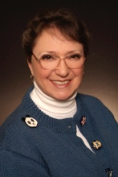

**President’s Notes**

Dear Fellow Club Members,

As I wrote this, I am recalling that at 9:30 am this morning our temperature was 72 degrees and now at 3:00 pm it is 34 degrees. Rather difficult to know when to start tuning up the senior citizen cars, isn’t it?

Want to remind you to call Joyce Smith at 918-346-9877, or if you know anyone who might like a get-well card or a thoughtful phone call.

Remember that on March 10th at 11:00 AM the nicely remodeled Circle Cinema Theatre, at Lewis and Admiral, will have a free viewing of one of Tom Mix’s films. This will be a great introduction to the April 7th trip our club will take to Dewey OK. to visit the Tom Mix Museum. Also on the agenda that day will be a visit to the historic Dewey Hotel and visits to some cute boutiques on the same street. Lunch will be at Dink’s for BBQ.

We have had two people volunteer for the calling committee, but we could use 3 or 4 more to help out with only 4 or 5 calls to make probably only once per month. Unless of course, if there is some emergency, it could happen twice per month.

Please remember to sign up with your anniversary dates at the next meeting, it will be published in the newsletter with the birthdays. It’s amazing how many long marriages there are to celebrate in our club.

The men’s lunch bunch is gaining more of a crowd. They meet every Wednesday at 11:30 AM at a different location each week. So, you might want to check with Chuck Mahan at 918-361-9081 to see which restaurant it will be at on the Wednesday that you can make it.

Speaking of Chuck, he is starting to work on our web site. So far, he has added the local and national events, and soon will be adding more information and deleting old data.

Hope you are all thinking about a joke or “thought for the day” at our next monthly meeting, March 4th at the usual place. Dan King will be presenting the program about “Spindletop”. Should be interesting.

Happy Motoring!

Sincerely,

Carolanne Mahan

AACA Tulsa Region President

**The AACA Tulsa Chapter**

**General Meeting Minutes**

**February 2017**

The February 4, 2018 AACA meeting was brought to order with President Carolanne Mahan leading us in the Pledge of Allegiance to the Flag. Treasurer Joe Smith was not in attendance.

The treasurers report was read by Carolanne and approved. The dues for 2018 are due.

There was no meeting in January so no minutes to read.

Ronnie Ferguson, a new member, was introduced to the membership. He was given a warm welcome.

Marylyn Baumann and Linda Beeson were both in attendance after having hospital stays. We wish both speedy recoveries.

New this year going to do 50-50 at the meetings. Also, a member can tell a joke or give a thought for the day. Then at the end of the year, members will vote on the best one, a prize will be given to the winner.

Men’s lunches are every Wednesday, call Chuck Mahan for location. Ladies’ lunches are the second Wednesday of the month at Egg It On, 81st street south and 145th east avenue in Broken Arrow.

Carolyn Plucknett is now at Saint Simeone’s. It would be nice if members would send her a birthday card on her 101st birthday, March 17th. The address is Carolyn Plucknett, Resident, Saint Simeone’s Senior Community, Asst. Plus, 3701 N Martin Luther King Blvd., Tulsa, Ok. 74106.

David Turner is purposing four AACA Tulsa Region Antiques Road Show 2018. First would be April 7th to drive antique automobiles, top speed 45 MPH on back roads. Meet for breakfast at IHOP in Owasso at 8:00 AM. Tour to Dewey, OK and visit the Tom Mix Museum. Next stop Dewey Hotel built by Jake Bartles for whom Bartlesville was named. Lunch at Dink’s in Bartlesville. Tour back to Owasso along a different route, disband back at IHOP. Please put it on your calendar.

Chuck Mahan had a quiz which couples could work on together, being Valentine’s Day is coming. A time limit of 15 minutes was given. With all correct answers Randy Beeson won the $20 gift card to Lowes.

Dismissed for cookies and conversation.

Respectfully Submitted,

Mary Jean Schaeffer

AACA Tulsa Region Secretary

AACA Runningboard Ramblings

*is published by the Tulsa Region of the Antique Automobile Club of America (AACA). The Tulsa Region is a non-profit organization chartered by AACA, Hershey, Pennsylvania. Tulsa Region dues are $20 due by March 1st annually. To comply with legal and insurance requirements, membership in National AACA is mandatory. Opinions expressed in this newsletter may not reflect those of AACA or the Tulsa Region. Runningboard Ramblings shall receive proper credit for material printed in other publications.*

**IMPORTANT DEADLINE INFORMATION: Deadline for submissions for the following month’s publication is the 15th of the previous month.**

BIRTHDAYS

March

5 Sandy Berenson

12 Joe Landers

31 Jim Jones

April

4 Pat DeBoer

15 Chuck Mahan

19 Russ Wolf

27 Shari Blair

ANNIVERSARIES

none

AACA Tulsa Region 2018 Board of Directors and Officers

President Carolanne Mahan 918 361-9081

Vice President & CEO Lee DeBoer 918 857-3022

Secretary Mary Jean Schaeffer 918 232-2288

Treasurer Joe Smith 918 346-9877

Members at Large: Melvin Burton 918 281-9443

Dan King 918 865-4399



***Sunshine Report***

*No illnesses have been reported. If you know of a member that is ill or could use a card - let me know and the club will send them a card.*

*Joyce Smith doggoneit101@yahoo.com or (918) 346-9987*

Editor: Dan King, *dcking1948@yahoo.com*

Web Site: www.tulsaregionaaca.org

e-mail: *AACATulsaRegion@gmail.com*

**AACA Tulsa Region 2018-19 Calendar**

*Month Day Activity Place Director Responsible comment*

**2018**

March 4 General Meeting ● Cooper Home ● post-meeting presentation Dan King

6 Tulsa Cruisers ● 91st & Memorial

7 Men’s Lunch ● 11:30 AM location TBD (call Chuck Mahan for details)

10 Silent Saturday ● Showtime 11:00 AM Circle Cinema 10 S Lewis, Tulsa OK

<http://circlecinema.com/portfolio/2nd-saturday-silents-riders-of-the-purple-sage-1925-310/> 14 Ladies’ Lunch ● 11:30 AM Egg It On Café 1131 S Aspen Ave, Broken Arrow

14 Men’s Lunch ● 11:30 AM location TBD (call Chuck Mahan for details)

21 Men’s Lunch ● 11:30 AM location TBD (call Chuck Mahan for details)

27 Board Meeting ● Fuddrucker’s Restaurant

28 Men’s Lunch ● 11:30 AM location TBD (call Chuck Mahan for details)

April 1 General Meeting ● Cooper Home ● post-meeting presentation Joe Smith

3 Tulsa Cruisers ● 91st & Memorial

7 Tulsa Region Cruise ● Tour to Dewey, OK

13 – 15 Tulsa Auto Show

May 1 Board Meeting ● Fuddrucker’s Restaurant

6 Gen’l Meeting ● Cooper Home ● post-meeting presentation Mary Jean Schaeffer

8 Tulsa Cruisers ● 91st & Memorial

June 5 Board Meeting ● Fuddrucker’s Restaurant

9 Annual Car Show hosted by AACA Tulsa Region

13 Tulsa Cruisers ● 91st & Memorial

23 Tulsa Region Cruise ● Tour to Pawhuska, OK

26 Board Meeting ● Fuddrucker’s Restaurant

July 1 General Meeting ● Cooper Home ● post-meeting presentation Melvin Burton

3 Tulsa Cruisers ● 91st & Memorial

31 Board Meeting ● Fuddrucker’s Restaurant

August 5 General Meeting ● Cooper Home ● Ice Cream Social

7 Tulsa Cruisers ● 91st & Memorial

28 Board Meeting ● Fuddrucker’s Restaurant

September 2 Annual Cookout ● Cooper Home ● Dan King ● bring a side dish

4 Tulsa Cruisers ● 91st & Memorial

8 Tulsa Region Cruise ● Tour to Oolagah, OK

25 Board Meeting ● Fuddrucker’s Restaurant

October 7 General Meeting ● Cooper Home ● election of 2019 Board Members ● post-meeting presentation Carolanne Mahan

3 Tulsa Cruisers ● 91st & Memorial

30 Board Meeting ● Fuddrucker’s Restaurant

November 4 General Meeting ● Cooper Home ● post-meeting presentation Dan King

11 Tulsa Veterans Day Parade

17 Tulsa Region Cruise ● Tour destination TBD

27 Board Meeting ● Fuddrucker’s Restaurant

December 2 General Meeting ● Cooper Home ● post-meeting presentation Joe Smith

TBD Christmas Dinner ● when and where TBD

**2019**

January 5 Installation Banquet ● time and location TBD

29 Board Meeting ● Fuddrucker’s Restaurant

February 3 General Meeting ● Cooper Home ● post-meeting presentation TBD

26 Board Meeting ● Fuddrucker’s Restaurant

Recurring Events

Every 2nd Saturday ● Silent Movie ● Circle Cinema 12 S Lewis ● Phil Judkins ● <http://circlecinema.com/>

1st Tuesday after general meeting ● Tulsa Cruise-In ● 91st & Memorial ● 5 pm – sunset (Mar – Oct) ● Dan King

**AACA National 2018-19 Calendar**

**2018**

March 3 Wilmington, NC ● North Carolina Region, Cape Fear Chapter ● 46th Annual Cape Fear Chapter AACA Antique Automobile Show ● Independence Mall, 3500 Oleander Dr.

3 Melbourne, FL ● Annual “Celebration of Cars” Antique to Modern Auto Show ● Cape Canaveral Region

4 Hamburg, PA ● Ontelanuee Region ● Swap Meet/Car Corral ● Hamburg Field House

10 Virginia Beach, VA ● Tidewater Region (TRAACA) ● Annual Swap Meet ● Military Aviation Museum, 1341 Princess Anne Rd, Virginia Beach, VA

10 West Friendship, MD ● Chesapeake Region ● 45th Annual Collector Car Swap Meet

10 – 11 Louisville, KY ● Kyana Region AACA Giant Indoor Swap Meet

● Kentucky Exposition Center Pavilion, West Wing, West Hall & Broadbent Arena

11 Englewood, FL ● Lemon Bay Region ● 31st Annual Classic Car Show ● Elks Lodge # 2378, 401 N Indiana Ave

17 41st Annual Antique Automobile Show ● Riverside Park, Vero Beach, FL ● Indian River Region

22 – 24 Mobile, AL ● AACA Winter Meet, sponsored by the Deep South Region AACA

24 Jefferson, OH ● Western Reserve Chapter Swap Meet ● Flea Market, Car Judging ● Ashtabula County Fairgrounds

24 Naples, FL ● Naples-Marco Region ● Classic Car Show ● Downtown Naples at Naples Depot Museum

25 Woodstown, NJ ● South Jersey Region ● 47th Annual Swap Meet and Car Corral at Salem County Fairgrounds

April 5 – 7 Southeastern Spring Meet ● Hornets Nest Region ● Charlotte, North Carolina

5 – 7 Greenville, TX ● Northeast Texas Region ● 19th Annual Swap Meet/Car Show ● Hunt County Fair Grounds

5 – 7 Greenville, TX ● Northeast Texas Region ● 19th Annual Swap Meet/Car Show ● Hunt County Fair Grounds

19 – 21 AACA Western Spring Meet ● Tucson Region ● Tucson, Arizona

28 Randleman, NC ● AACA North Carolina Region Spring Meet ● Petty's Garage ● General Greene Chapter

29 Charlottesville, VA ● Piedmont Region AACA ● 44th Carfest ● 970 Hilton Heights Rd

May 5 – 6 Ontario, Canada ● AACA Ontario Region's 47th Annual Antique Automotive Flea Market ● Lindsay Fairgrounds

5 – 7 Lawrence, KS ● Lawrence Region ● 55th Annual Swap Meet ● 4H Fairgrounds

6 Morristown, NJ ● New Jersey Region ● 67th Annual Car Show & Flea Market & Car Corral ● The Mennen Arena 161 E Hanover St Morristown, NJ

11 – 12 Central Spring Meet ● Auburn, Indiana

18 – 20 50th Dunkirk Automotive Swap Market/Flea Market ● Dunkirk, NY ● Chautauqua Lake Region

20 Saratoga Springs NY ● Saratoga Region ● Annual Saratoga Automobile Museum Car Show ● Saratoga Springs State Park

26 – 27 Norwich, NY ● Rolling Antiquers Old Car Club (RAOCC) Antique Auto & Muscle Car Shows ● Chenango County Fairgrounds 168 East Main St., Norwich, NY

28 Boalsburg, PA ● Allegheny Mt Region ● Memorial Day Annual Auto Show ● PA Military Museum

31 – 2 Annual Grand National Meet ● Western PA Region ● Greensburg, PA

June 3 Liverpool, NY ● Oneida Lake Region ● 65th Annual Show in the Shade ● Clay Town Park 4821 Wetzel Rd, Liverpool, NY

9 York Springs, PA ● Gettysburg Region ● 43rd Annual Antique Classic Auto & Truck Show ● Latimore Valley Fair Grounds, York Springs, PA

24 Forty Fort, PA ● NE PA Region ● 57th Annual Car Show & Flea Market ● WYOMING VALLEY AIRPORT, FORTY FORT, PA

25 – 29 Lock Haven, PA ● Eastern Divisional Tour ● hosted by Bob Giles and Tom Roberts ● Limited to 25 cars built between 1940-1955

July 1 McAdoo, PA. Anthracite Region ● 33rd Annual Car Show ● Tri-County Little League Baseball Field

11 – 14 AACA Eastern Spring Meet ● Chesapeake Region ● Gettysburg, PA

21 Pine Grove, PA ● Buddy's Log Cabin Family Restaurant ● Annual Car Show

August 20 – 24 AACA Reliability Tour ● GVACS & Wayne Drumlins Region ● Canandaigua, NY

25 Groton, NY ● Groton Olde Home Days Antique & Classic Car Show

September 12 – 15 AACA Central Divisional Tour ● Amarillo Region ● Texas Panhandle

16 – 21 AACA Glidden Tour ● VMCCA ● Twin Falls, ID

October 10 – 13 AACA Eastern Fall Meet ● Hershey, PA ● Hershey Region

21 – 26 AACA Founders Tour ● Metropolis, IL ● Southern Illinois Region, Ohio Valley Chapter

November 5 – 9 AACA Sentimental Tour ● Natchez, MS ● Louisiana Region

**2019**

February 7 – 9 AACA Annual Meeting ● Philadelphia, PA

21 – 23 AACA Winter Meet ● Ocala, FL ● Kingdom of the Sun Regions

April 4 – 7 AACA Southeastern Spring Meet ● Hornets Nest Region ● Charlotte, North Carolina

May 9 – 11 AACA Annual Grand National Meet ● Auburn, IN.

June 2 – 7 AACA Founders Tour ● Nebraska Region ● Seward, NE

September 19 – 21 AACA Southeastern Fall Meet ● Cleveland, TN ● Cherokee Valley Region

October 9 – 12 AACA Eastern Fall Meet ● Hershey, PA ● Hershey Region

***Tom Mix movie at Circle Cinema***

Below is a link to the Circle Cinema web site advertising the silent movie for 10 March.    It is none other than ***Riders of the Purple Sage*** staring Tom Mix and all tickets are free!    Plan to attend the movie on 10 March and then plan to travel with the Region in our antique automobiles to the Tom Mix Museum in Dewey, OK on Saturday 7 April.  See details elsewhere in the newsletter.

<http://circlecinema.com/portfolio/2nd-saturday-silents-riders-of-the-purple-sage-1925-310/>

David Turner

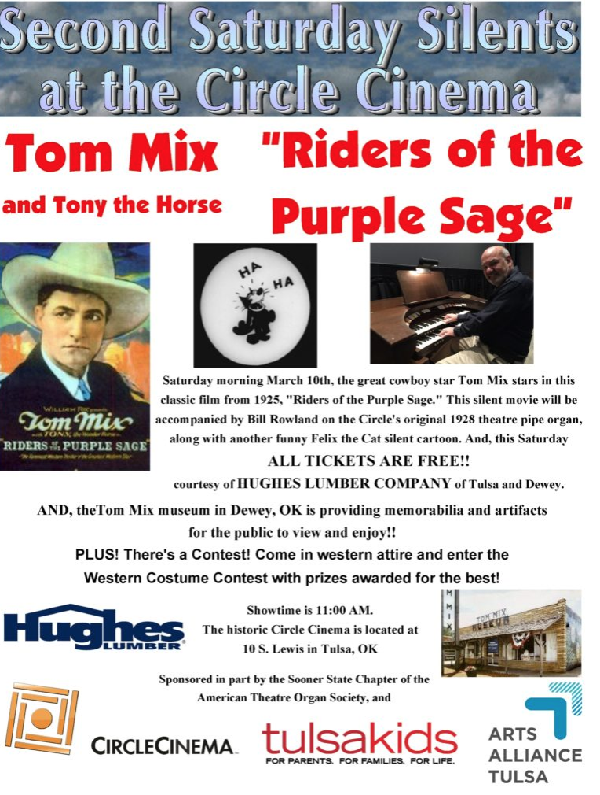

AACA Tulsa Region Antiques on Parade for 2018

Quarterly tours for our antique automobiles

*Submitted by David Turner*

Members are encouraged to drive their antique automobiles on these tours so that we can show them off to the public. We hope that each participating antique automobile will be equipped with magnetic door signs which will identify our club and give some organization to our tour. (See the article elsewhere in this newsletter on how to procure them for $65.00 a pair). Members who don’t currently have an operating antique automobile to drive are encouraged to hitch a ride with a member who does. We will not prohibit the use of modern cars but are trying to discourage their use. Participating modern cars will not display magnetic door signs and will drive at the rear of the tour. Each of these tours are proposed as caravans (follow-the-leader). All tours will occur on Saturdays. In case of rain or other bad weather – stay home – tour cancelled!

**APRIL 7TH**

**Tour to Dewey, OK (avoiding US-75 both ways – top speed 45 mph**

Meet for breakfast at IHOP in Owasso at 8:00 AM

Tour to Dewey, OK

Tour the Tom Mix Museum and/or

Tour the restored Dewey Hotel built by Jake Bartles for whom Bartlesville is named or shop the antique shops on Don Tyler Ave.

Lunch at Dink’s Bartlesville

Tour back to Owasso along a different route

Disband at IHOP

**JUNE 23rd**

**Tour to Pawhuska OK – top speed 50 mph or less - TBD**

Meet for breakfast at IHOP in Owasso

Tour to Pawhuska, OK on back roads and then seven more miles north from Pawhuska to the entrance of the Joseph H. Williams Tallgrass Prairie Preserve and the end of the pavement. After a short stop and visit we will return on the same road to Pawhuska

Tour Richard DeMoss taxidermy shop (tentative) and/or

shop the Mercantile etc. - lots of new shops on Main Street and on Kihekah Ave.

Lunch at Buffalo Joes or Bad Brad’s BBQ

Tour back to Owasso on a different back roads route

Disband at IHOP

**SEPTEMBER 8TH**

**Tour Rogers County roads to Oolagah, OK – top speed TBD**

Meet for breakfast at IHOP in Owasso

Tour to Oolagah, OK on back roads

Tour the Will Rogers childhood home

Tour to Foyil – Bunion Derby monuments and Totem Pole Museum

Lunch possibly in Pryor Creek – site to be determined

Tour back to Owasso on back roads

Disband at IHOP

**NOVEMBER 17TH**

**Fourth Tour – Destination to be determined – ideas?**

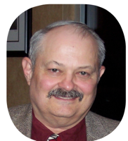 *One Hundred Years Ago Today*

*by Randy Beeson*

Faced with an internal counterrevolution and a renewed German offensive, Russia signed the Treaty of Brest-Litovsk on March 3rd. Germany ­immediately began transferring troops, along with Generals von Hindenberg and Ludendorff who would assume command, to the Western Front. During the period of March 21st-28th, Germany launched the Somme offensive along a 50-mile wide front, her final major attempt to win WWI before American troops were fully prepared and committed to the ‘meat grinder’. On the 23rd, German long range ‘Paris Guns’ opened fire on Paris from a distance of 75 miles, killing 256 residents. Each gun was manned by 80 Imperial Navy sailors and each shell was in flight more than three minutes. By the same date, German forces had advanced 14 miles to the Somme River and Allied forces were in retreat.

On Sunday, March 24th, Catholic and Protestant churches in Washington, DC offered prayers for Allied troops trying to stem the German ‘sturmtruppen’ assault. British troops were bearing the brunt of the fighting.

On March 4th, the first case of Spanish flu was officially diagnosed at Camp Funston, KS. On the 11th, the first case was diagnosed at Ft. Riley, KS. Before it petered out in the early 1920s, some 50-100 million people worldwide would die. The flu was particularly lethal for the young whose stronger immune systems flooded the lungs with body fluids in a hyper-response to the virus. As a result, many young victims drowned in their own body fluids. Movement of troops from and between training camps to East Coast port cities for embarkation to Europe facilitated the virus’s rapid spread.

Political ferment continued in Europe with Finland forming an alliance with Germany on March 7th. The Russian Bolshevik Party became the Communist Party on the 11th. Lithuania declared her independence on the 23rd and the Belorussian People’s Republic was proclaimed two days later.

Here at home, the U.S. Congress approved the creation of time zones and use of Daylight Saving Time on the 19th. Daylight Saving Time went into effect on March 31st.

Famous births this month included mystery writer Mickey Spillane, born in Brooklyn, NY on March 9th. Actress Mercedes McCambridge was born in Joliet, IL on the 17th, while sportscaster Howard Cosell was born in Winston-Salem, NC on the 25th. Singer Pearl Bailey was born in Newport News, VA on March 29th, the same day Wal-Mart founder Sam Walton was born in Kingfisher, OK.

In other news, 17-year old jazz musician Louis Armstrong married 21-year old Daisy Parker on March 19th while noted French composer Claude Debussy died in Paris on the 25th.

Despite rumors to the contrary, on March 19th, John Dodge of the Dodge Brothers Motor Car Company formally announced that he would not be a candidate for U.S. senator. The March 7th issue of the Indianapolis News carried a notice from L.H. Van Briggle, receiver for the assets of the States Motor Car Company for the sale of the remaining few units of the State Touring Car, while O.M. Jones advertised his newly overhauled and repainted two-year old Chevrolet Baby Grand for sale. Gee, they don’t make cars like they used to!

Gasoline Alley

*By Dan King, Editor*

***Thomas Flyer Won the New York to Paris Race***

*by Tad Burness*

The Thomas Flyer is the car that won the famous New York to Paris race in 1908.

Six cars competed. In addition to the American Thomas, there was the German Protos, the Italian Brixia-Zust, and three French cars: The De Dion-Bouton, the Motobloc, and the smallest car in the race – the Sizaire-Naudin.

Body and Fenders of the Thomas Flyer were altered for the race. In fact, all the cars looked homely as peddler wagons, laden down with items needed for the long trip.

First car in trouble was the Brizia-Zust. It broke a transmission chain and its radiator cracked not long after the race began. But it was repaired.

A blizzard hampered the cars only 20 miles from starting point.

And because of the poor roads in 1908, there were many pitfalls along the way.

Going west across the U.S., the Thomas moved into the lead. Meanwhile, the Sizaire-Naudin had quit the race after less than 100 miles, because a gear broke in the rear axle and no spare parts were available. In Cedar Rapids, Iowa, the Motobloc was withdrawn because its team was discouraged.

From San Francisco, the Thomas was carried by boat to Alaska. But after the Thomas reached port April 8th, it was decided that melting snows would make an Alaskan crossing impossible.

Forewarned, the Brixia-Zust and De Dion teams were allowed to bypass the planned Alaska route, and were shipped from Seattle to Japan. The Protos was shipped to Russia, after a temporary disqualification, bypassing Japan.

Though the Protos was the first car to reach Paris (on July 26), the Thomas won by a decision because it was the only car that had attempted the full original route.

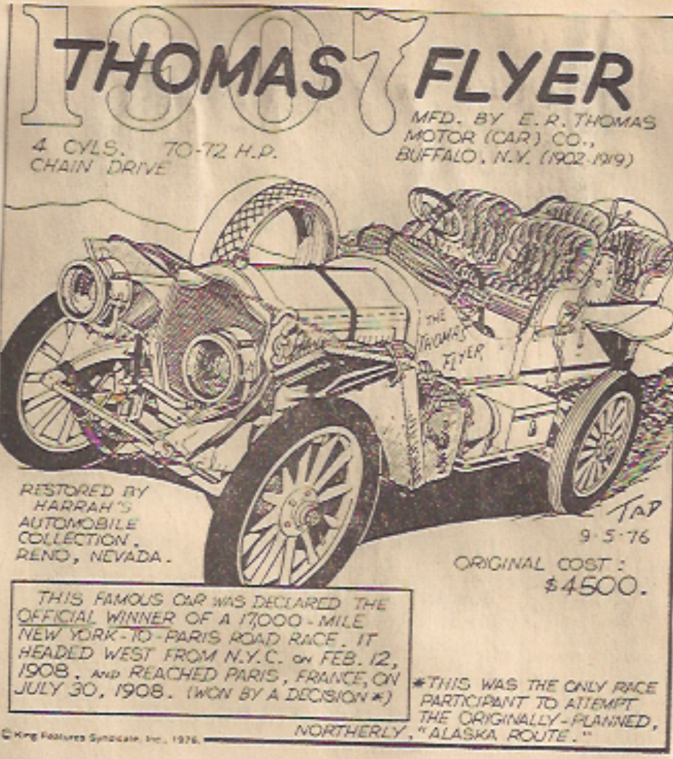

8/17/80 by Tad Burness, Copyright 1980 United Feature Syndicate

*Editor’s Note: Charles Schaeffer’s scrapbook of almost 200 articles clipped from the Tulsa World were the creation of Tad Burness, whose biography can easily be found on the internet. The scrapbook was given to me by Mary Jean Schaeffer, who currently serves as a Board Member and club Secretary.*

**Share Your Story!**

Our club newsletter, **Runningboard Ramblings**,is only as good as you make it. We want to hear from you!  We are always looking to feature articles from Tulsa Region members about your personal accounts of tours and shows you have attended, restoration projects, unique vehicle stories and history, and any other stories you think other AACA members would enjoy hearing about. And, of course, include plenty of photos to make your story come alive! Please send in your photos and stories to Dan King, [dcking1948@yahoo.com](mailto:dcking1948@yahoo.com).

*Later alligator …*

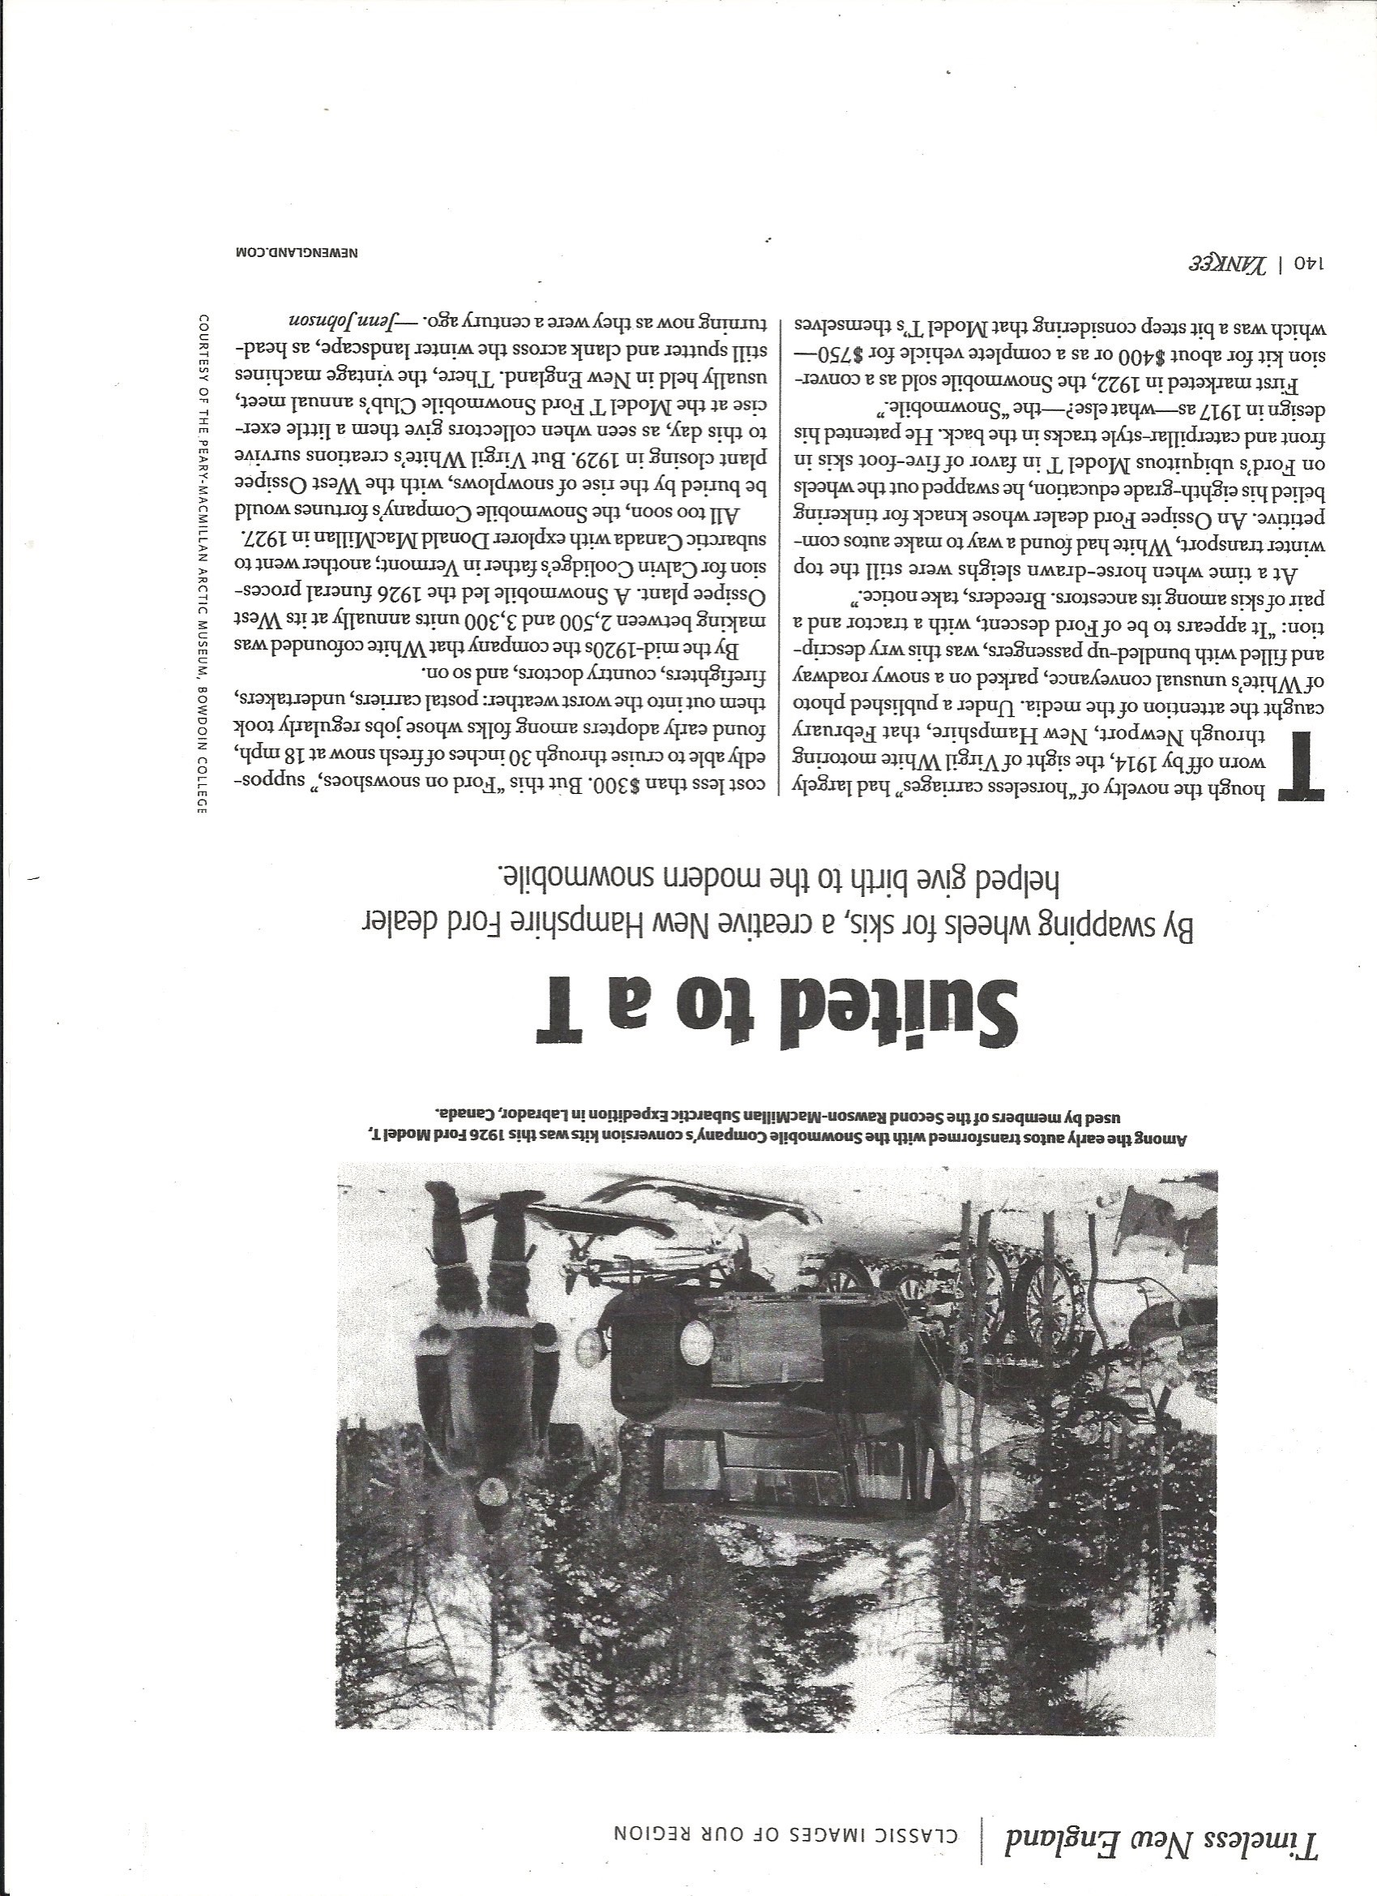

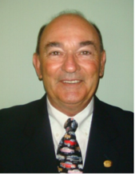 **Let’s Make a New Year’s Resolution!**

*Wayne Tuck*

*Vice President, Membership*

How many of you have ever made a New Year’s Resolution? Lose weight? Go to the Gym three times a week? Get the house trim painted? Get that old car out and drive it at least once a month? I’m sure many of us have made some type of resolution.

Now how many of you have broken that resolution? We usually have some excuse. Sometimes circumstances just make it impossible to accomplish. Sometimes our resolutions are overly ambitious.

Let me suggest we make a resolution that we can all accomplish if we put in a little effort. Sign up a new AACA member. That doesn’t sound too hard does it? The world is full of old car fans. Shouldn’t they all be members?

Stacy Zimmerman’s recent Speedster article regarding AACA being a “Best kept secret” was a real eye opener. We all know what a great organization it is and all the benefits AACA has to offer. Why aren’t we out there spreading the word? Most of us pay a lot more attention to a friend or acquaintance making a referral or recommendation than we do to paid advertising. Why keep it a secret?

I challenge you to each join me in celebrating the new year with the following resolution:

I resolve to sign up at least one new AACA member in 2018!

**Car Show Windshield Cards**

*By David Turner*

As announced at the meeting a few months ago, I am willing to make laminated windshield cards for any member who wishes one for their car(s). All I ask is $3.00 to cover the cost of materials and laminating. The lamination is 10 mils thick and quite rigid. As a result, they should be less likely to blow off the windshield in a heavy wind. They will all be 8.5” x 11” on white card stock. If you wish to order one, contact me or any of the club board members. An example shown below.



David Turner can be contacted by e-mail at drenrut@cableone.net or phone 918-527-9560.

**AACA Tulsa Region Magnetic Signs**

You, too, can look as cool as Phil by ordering your very own AACA Tulsa Region magnetic signs. The folks who see your car on display or on parade will know that you are a member of

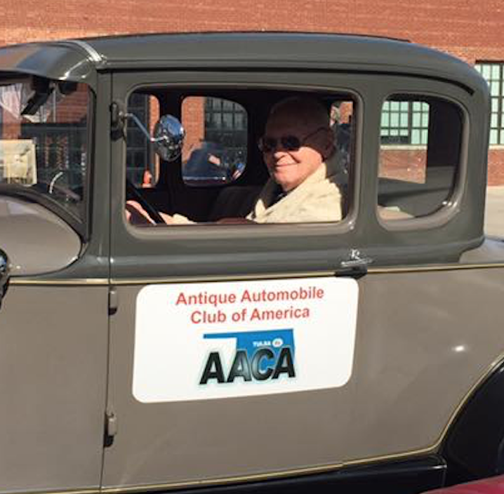

the best car club of all. The cost is $65.00 plus $5.53 equals $70.53. The supplier is A&B Identity and to keep it simple they would prefer that all the orders come through me, so give me your order and make your reimbursement check payable to me. Lead time is about two weeks. Let’s put our best foot forward for all our public events.

 

Antique Automobile Club of America – Tulsa Region

Membership Application/Renewal Form

To insure accuracy in our Membership Roster please send us your information:

Name: ____________________________________ Spouse: _________________________________

Address: ______________________________________________

City: _______________________________ State: ____________________ Zip: __________________

Preferred Phone: ___________________ Alternate Phone: _________________________________

Email: ____________________________________________

Your Birth Month and Day: _____________ Spouses Birth Month and Day: ________________

Your Anniversary Month and Day: _____________________________________________________

Your National AACA membership number: _____________________________________________

Your Cars

Year: _________ Make: __________________ Model: _________________ Body Style: __________

Year: _________ Make: __________________ Model: _________________ Body Style: __________

If you have more cars, please list them on the back of this form.

Send a photo of your car(s) if you would like it to appear on the Region web page.

Send this completed form to:

Mary Jean Schaeffer

6529 E 74th St

Tulsa, OK 74133

[chas4744@att.net](mailto:chas4744@att.net)

AACA *Runningboard Ramblings*

Editor: Dan King

872 North Basin Road

Mannford, OK 74044

